Muhammad Zeeshan & Hamza Shabbir

BSEE 18-22  A Section Group 14

the use of photoplethysmography in Health Monitoring.

# Abstract:

This report summarizes the use of photoplethysmography in monitoring health of patients. It uses a noninvasive technology to measure many factors associated with changes in blood flow in human body. PPG sensors are widely available in the market these days and they are used to measure blood oxygen level, blood pressure, stress levels, hypertension, and many other factors. Due this technology being noninvasive it is very convenient cheap and readily available. Photoplethysmography (PPG) is a simple optical technique used to detect volumetric changes in blood in peripheral circulation. It is a low cost and non-invasive method that makes measurements at the surface of the skin. This report is part of a Complex Engineering problem of electrical engineering. In this report we have discussed various techniques, principles, Optical instrumentation, applications and commercially available devices for PPG measurements and instrumentation.

Contents

Abstract: 1

Introduction: 3

Techniques: 3

Principle of operation for PPG 5

Photoplethysmography assessments in cardiovascular disease: 5

Photoplethysmography: 6

Optical instrumentation: 7

PPG transducer: 7

PPG probes 8

PPG amplifier: 8

Constant LED current source: 9

Multi-channel PPG capability: 9

PPG measurements 10

Second derivative wave of PPG signal: 10

Applications: 12

Uses of PPG 12

Wearable Devices 13

Pulse Oximeter Fingertip: 13

Finger clips sensor 14

Sana Health 15

OneCare 15

Kenzen Wearable patch system: 16

Phlex: 16

Discussion: 17

Conclusion: 17

# Introduction:

Photoplethysmography (PPG) is a simple optical technique used to detect volumetric changes in blood in peripheral circulation. It is a low cost and non-invasive method that makes measurements at the surface of the skin.

The word plethysmography means methods for recording volume changes of an organ or a body part. Depending on the technique used, strain gage, impedance, and optical techniques can be used for the volume determination.

Although Photoplethysmography is simple and indicates timing of events such as heart rate, it provides a poor measure of changes in volume, and it is very sensitive to motion artifact.

# Techniques:

The principle on which photoelectric plethysmography (PPG) is based is simple. A beam of light is directed toward the part of the tissue in which blood flow (or volume) is going to be measured (Figure 1). Reflected, transmitted, and scattered light leaving this volume is collected and focused on a photodetector. A signal modulated by the attenuation or scattering of light in the blood volume can be recorded. Two different components can be derived from the detector. One is pulsatile and synchronous with the heartbeat (the ac component), and the other is a constant voltage (the dc component). The physiological significance of the two signals is still under debate, but they reflected the blood volume and the orientation of erythrocytes during the cardiac cycle.

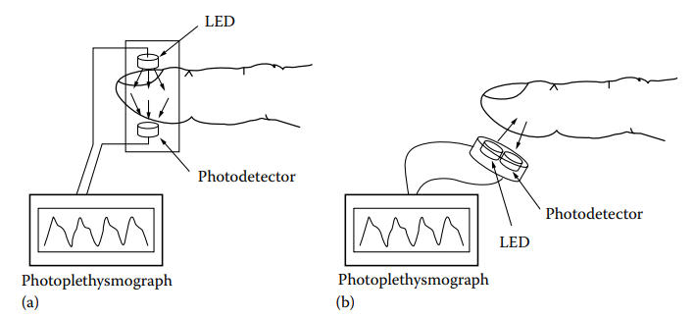

Figure 1: For photoplethysmography, increased blood decreases received light in (a) transmission mode and (b) reflection mode.

Photodiode

Green LED’s

## Principle of operation for PPG

The light interaction with tissue processes is complex in most optical physiological measurements. The basic principle of PPG16 is as follows: to the eye, the human body appears opaque to light transmission. However, most soft body tissues will transmit optical radiation in the visible and near-infrared wavelengths. For example, if visible light, such as a torch beam, is placed on the palm of the hand in a darkened room. The transmitted light can be seen on the back of the hand as a red glow. The transmitted light is colored red because of the selective absorption by tissue pigments, and specifically by hemoglobin in the red blood cells. A halo of back-scattered light around the torch can also be seen. The volume of the red blood cells changes in synchrony with each heartbeat and results in small but significant changes in the light transmitted and backscattered. This pulsatile component is quite small relative to the average transmitted light and is not easily seen with the naked eye. Instead, it can be picked up by an optical detector placed on the skin on the back of the hand. PPG is based is the detection of these small changes in the altered light which occur with each pulse. The greater the changes in blood in the sample volume then the greater the light source is attenuated. There is usually a pulsatile (AC) component with fundamental frequency close to 1 Hz, depending on the heart rate, and superimposed on a quasi-DC component which relates to the average blood volume in the tissue. DC varies slowly due to respiration, vasomotor activity, blood pressure and thermoregulation. AC and DC can be measured and separated using electronic amplification and filtering stages.

## Photoplethysmography assessments in cardiovascular disease:

Claudication is pain caused by too little blood flow to muscles during exercise. Claudication is technically a symptom of disease, most often peripheral artery disease, a narrowing of arteries in the limbs that restricts blood flow.

Treatments focus on lowering the risks of vascular disease, reducing pain, increasing mobility and preventing damage to tissues. Peripheral artery disease is a sign of poor cardiovascular health and an increased risk of heart attack and stroke.

**Ischemia** [or](https://en.wikipedia.org/wiki/American_and_British_English_spelling_differences#ae_and_oe) **ischaemia** is a restriction in [blood](https://en.wikipedia.org/wiki/Blood) supply to [tissues](https://en.wikipedia.org/wiki/Tissue_(biology)), causing a shortage of [oxygen](https://en.wikipedia.org/wiki/Oxygen) that is needed for [cellular metabolism](https://en.wikipedia.org/wiki/Cellular_metabolism) (to keep tissue alive).[[3]](https://en.wikipedia.org/wiki/Ischemia#cite_note-3) Ischemia is generally caused by problems with [blood vessels](https://en.wikipedia.org/wiki/Blood_vessel), with resultant damage to or dysfunction of tissue.

Gangrene refers to the death of body tissue due to either a lack of blood flow or a serious bacterial infection. Gangrene commonly affects the extremities, including your toes, fingers and limbs, but it can also occur in your muscles and internal organs.

The circulating medium, blood, is essential for life and provides nutrients such as oxygen and glucose to the muscles, and removes waste by-products. Impairment of this finely regulated system can result in peripheral vascular disease (PVD).

It would probably not be cost-effective for doctors to screen every patient presenting with symptoms of vascular disease. Ideally, what is needed is an initial vascular screening assessment which accurately determines if a patient has normal arteries or if they should be referred to a specialist for a thorough cardiovascular assessment.

Peripheral vascular disease can lead to disabling claudication symptoms, critical limb ischaemia, gangrene, and even loss of life. The simple, non-invasive, and low-cost optical physiological measurement technique photoplethysmography (PPG) has the potential to screen for such disease.

## Photoplethysmography:

PPG shows the blood flow changes as a waveform with the help of a bar or a graph. The waveform has an alternating current (AC) component and a direct current (DC) component.

The AC component corresponds to variations in blood volume in synchronization with the heartbeat. The DC component arises from the optical signals reflected or transmitted by the tissues and is determined by the tissue structure as well as venous and arterial blood volumes.

The DC component shows minor changes with respiration. The basic frequency of the AC component varies with the heart rate and is superimposed on the DC baseline.

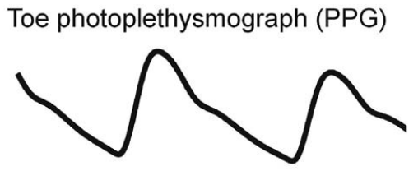

Figure : Photoplethysmography AC waveform from the toe site of a healthy subject over a few seconds. PPG detects the pulsatile changes in blood volume in the tissue vascular bed with each heartbeat.

# Optical instrumentation:

## PPG transducer:

A semiconductor light emitting diode (LED) source is often used instead of the torch example mentioned earlier, with the LED wavelength fixed within the near infrared range 0.8 to 1.0 µm. LEDs have considerable advantages; they have a narrow bandwidth, are small and low-cost, mechanically robust, and have a long operating life. The intensity of the LED is often chosen to be small to reduce local tissue heating. The optical radiation backscattered from the tissue can be detected with a photodiode matched to the LED wavelength. Photodiodes have the capability for producing an output linearly proportional to the incident light, are compact and low-cost, have fast response times, and are sensitive. The LED and photodiode are packaged either side-by-side (‘reflection mode’) or can be placed either side of the tissue (‘transmission mode’). Reflection mode PPG is often the mode of choice in vascular assessments since it allows easy attachment to the many peripheral sites including the ear lobes, and finger/toe tissue pads. Here, movement and ambient light artefacts can be reduced by suitable fixation, such as with a (black) Velcro wrap-around cuff (e.g. for the finger and toe sites) or covered spring-loaded clip (e.g. for the ear site).

## PPG probes

There are several types of PPG probes that are commercially available. PPG research carried out at Freeman Hospital has utilized the Artema (Denmark) range of pulse pick-up probes (ear probe type 75331-9, and toe/finger probe type 75333-5). Their operating wavelength is 950 nm using constant low-level tissue illumination (with output power less than 5 mW).

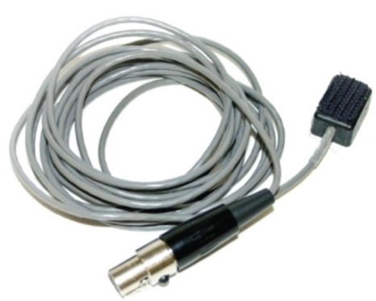

## PPG amplifier:

The generic structure for a PPG amplifier involves a transimpedance amplifier stage to convert the photodiode current signal to a proportional voltage23. The simplest form of transimpedance amplifier requires only an operational amplifier with feedback and offset resistors. The choice and layout of these components are crucial to obtain low-noise pulse waveforms. Meticulous cable screening is also needed to reduce contamination by electromagnetic interference. The voltage signal is high-pass filtered to reduce the dominant lower frequency (DC) PPG components, leaving the AC pulsatile component for further processing. A low-pass filtering stage with additional electrical mains frequency notch filtering then smooth the signals. The choice of high-pass filter cut-off frequency is important for PPG measurements as excessive filtering will distort the pulse shape11. Typically, the PPG filter bandwidth is chosen to be in the range 0.05 to 20 Hz.

## Constant LED current source:

A constant-current generator source can be used for the transducer LED illumination. The electronic design should aim to minimize the noise on the LED signal, and tight current control is required when studying the low-frequency (DC) components of the PPG waveform over periods of several tens of minutes.

## Multi-channel PPG capability:

There are advantages in studying several body sites simultaneously to give representative information about the whole cardiovascular system8. This can be achieved using multi-channel channel photoplethysmography (Figure 3).

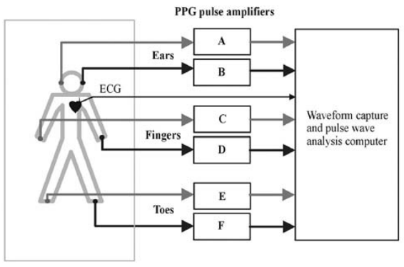

Figure : Multi-channel photoplethysmography. In this example pulses are collected from PPG pulse transducers at different body sites and signal conditioned using the PPG amplifier units (A to F).

## PPG measurements

Photoplethysmography is undertaken in a clinical measurement environment (ideally normo-thermic at approximately 23o C). The subject should be rested for a period of at least 10 minutes before pulse measurements commence. The PPG transducers are then carefully applied. The subject is asked to relax and breathe gently and regularly throughout the recording. A PPG recording typically lasts a few minutes when assessing just the AC characteristics of the pulse and several tens of minutes when assessing the DC characteristics.

# Second derivative wave of PPG signal:

The second derivative wave of the original PPG signal is called the acceleration photoplethysmogram (APG), and it is more commonly used than the first derivative wave. APG is an indicator of the acceleration of the blood. Figure 3 shows the original PPG signal along with its first and second derivative waves. There are several critical points that can be extracted from the second derivative wave of a PPG signal. These critical points can be used to detect and diagnose cardiac abnormalities. In clinical and research settings, there are still ongoing efforts to improve the current methods of obtaining critical points from the second derivative wave of the PPG signal. Figure 3 shows only three critical points that were extracted from the original PPG signal. critical point a is the early systolic location. Point b is the lowest point in the early systolic wave. Point c is the resurgent of late systolic. Point d indicates the decreasing part of late systolic and point e represents the early diastolic wave. From the second derivative, we can compute the large artery stiffness index. The APG correlates with the distensibility of the carotid artery, age, blood pressure, risk of coronary heart disease, and the presence of the atherosclerotic disorders. PPG describes how fast blood moves within blood vessels. Systolic and diastolic waves interact with each other to form a waveform that resembles a long curve with varying troughs and rests that represent the critical points as stated before. The positive waves, namely the a, c, and e waves, rest above the baseline and have positive values, while b and d are negative waves. Thus, the latter waves lie below the baseline due to their negative values. The relationship between the waves represents different physiological trends found in subjects. For example, the ratio b/a represents increased arterial stiffness that increases with age. This ratio can also indicate hypertension. Potential work includes examining the relationship between a/b and studying the impact of age, body mass index, and core temperature on PPG waves. There are algorithms that can detect a-waves and b-waves, but not accurately. To analyse the results of a PPG experiment, there needs to be a clear and accurate assessment of these waves to determine future steps to be taken for the assessment of arterial stiffness and other cardiovascular diseases that may be present.

Figure A Figure B

Figure C

# Applications:

For a patient who remain quiet, the photoplethysmography can measure heart rate. It offers an advantage that it responds to the pumping action of the heart and not to the ECG. When properly shielded, it is unaffected by the use of electro surgery, which usually disables the ECG. However, when the patient is in a state of shock, vasoconstriction causes peripheral flow to be greatly reduced and the resulting small output may make the device unusable. To prevent this problem, the device has been used to transmit light through the nasal septum

PPG has great potential to assess the age-related changes in arterial stiffness, an accepted cardiovascular risk factor.

## Uses of PPG

Medical devices based on PPG technology are widely used in various applications in the clinical set up.

Specific applications include the following:

* Clinical physiological monitoring
* Blood [oxygen saturation](https://www.news-medical.net/health/What-is-Oxygen-Saturation.aspx)
* Blood pressure
* Cardiac output
* Heart rate
* Respiration
* Vascular assessment
* Arterial disease
* Arterial compliance and ageing
* Venous assessment
* Endothelial function
* Microvascular blood flow
* Vasospastic conditions
* Autonomic function monitoring
* Vasomotor function and thermoregulation
* Blood pressure and heart rate variability
* Orthostasis
* Other cardiovascular variability assessments

## Wearable Devices

Using this technology, wearable pulse rate monitors have been developed. These low-cost and small devices have high-intensity green light-emitting diodes (LEDs) and photodetectors that help reliable monitoring of the pulse rate in a non-invasive manner.

Important design requirements for these systems include miniaturization, robustness, and user-friendliness.

Pulse Oximeter Fingertip: There are many pulse oximeters in use these days. These devices were around but they were strongly recognized during the COVID-19 Pandemic as patients with COVID-19 had breathing problems and this device was used to measure their oxygen level in the blood using light absorption in oxygenated and deoxygenated blood. There are many of these devices available in the market or Amazon.

Finger clips sensor manufactured by Kyto Electronics. Finger pulse sensor HRM-2511B.

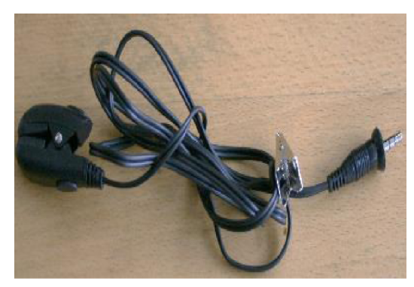

Sana Health has made a maskand headphones to wear overhead. it uses audio visual stimulation to increase balance between the left and right side of the brain leading to greater relaxation. Prolonged usage of this device will track patterns and will help to accelerate physical recovery and improve mental health and wellbeing. The device uses visual stimulations at low levels of light through closed eyes and heart rate variability measurement. coordinated pulses of light and sound guides the user into a deep state of relaxation, promoting increased recovery from fatigue and this data is connected to mobile app.

OneCarehas made a wearable watch that uses PPG sensors to remote watch patients and alert a guardian if anything goes wrong. It tracks their steps, heartrate and sleep monitor, location information, fall detection and SOS alert and send that data over the network to the guardian of the person via mobile app. Its connected to AT&T cellular network. It also provides data analytics so that doctors can track the trends. Companies such as Samsung and Apple also use this kind of tech in Samsung and Apple watch.

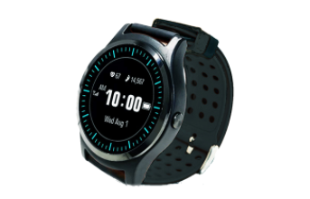

Kenzen Wearable patch system: This system is a wearable patch system to improve worker health and safety. The Kenzen patch continuously measures vital and factors associated with heat stress and tracks health of workers Working in extreme conditions such as coal mines and other construction sites.

Phlex: made a device using heart rate data to improve swimmer’s performance. Its main objective is for all swimmers to get the most out of their training.

Bodytrak: developed a solution for precise physiological monitoring using an earpiece providing automated real time data, audio, and predictive cloud-based analytics. The earpiece has sensor integration, audio alerts and onboard data processing and it is connected to a powerful system processing and communication.

# Discussion:

Photoplethysmography (PPG) is a simple optical technique used to detect volumetric changes in blood in peripheral circulation. It is a low cost and non-invasive method that makes measurements at the surface of the skin. Monitoring of heart rate during daily routine activities physical exercise and monitoring of patients is an important feature in many modem wearable devices such as wristbands and smart watches and many other devices. Obtaining high quality PPG signals during physical exercise is difficult and challenging as PPG signals are usually contaminated by very strong motion artifacts caused by subject’s hand movements. This area of research has been very popular for the past few years and many leading high-tech companies and academics have been actively working on this topic. Currently researchers are investigating the effects of motion artifacts on the quality of acquired PPG signals and proposing solutions to mitigate or ideally remove this destructive affects. Accelerometer is used in some cases to remove the motion artifacts.  Scientific interest has continued to look beyond the pulse oximetry and heart rate calculation, and more into the potential applications of PPG sensors. It is now well known that the second derivative wave of the original PPG signal contains important health-related information, and the analysis of this wave could lead researchers, clinicians, and health-care providers to the early detection and diagnosis of various cardiovascular diseases typically occurring later in life.

# Conclusion:

The use of photoplethysmography in Health Monitoring has been around for a while in research and commercial use but it has really seen spike in usage during the pandemic. Recently pulse oximeters were in high demand as people with COVID-19 needed them to monitor their blood oxygen levels as they have respiratory problems and they have often got low Spo2 levels, so they must continuously monitor them. PPG has many applications despite Spo2 levels that is to measure stress, blood pressure, respiratory rate, diagnose cardiovascular disease such as vascular aging and many more. More than 3.8 billion people around the world do not even have basic heath facilities available. PPG sensing is an important technology for the future in health monitoring both remotely and on site and due to its non-invasive nature, it can prove itself more convenient, cheap and more and more people around the world can have basic health facilities and can make a better and healthy society.

References:

1. J. G. Webster, Ed., Medical Instrumentation. Application and Design, 4th edn., John Wiley & Sons, New York, 2010, pp. 332–338.
2. <https://journals.sagepub.com/doi/pdf/10.1177/002029400603900303>
3. AbuRahma, A. F., and Diethrich, E. B., Current Non-Invasive Vascular Diagnosis, Massachusetts: PSG Publishing Company, 1988.
4. <https://valencell.com/ppgsensors/>
5. <https://www.ncbi.nlm.nih.gov/pmc/articles/PMC6426305/>